**EIT Pupil Passport**

**Name _________________________ School_____________________________________**

**My strengths**

|  |
| --- |
| **When I struggle, I…..** |

|  |  |  |  |
| --- | --- | --- | --- |
| **You can do this to help me….** | | | |
| **Targets**  **I am learning to….** | **Review** |

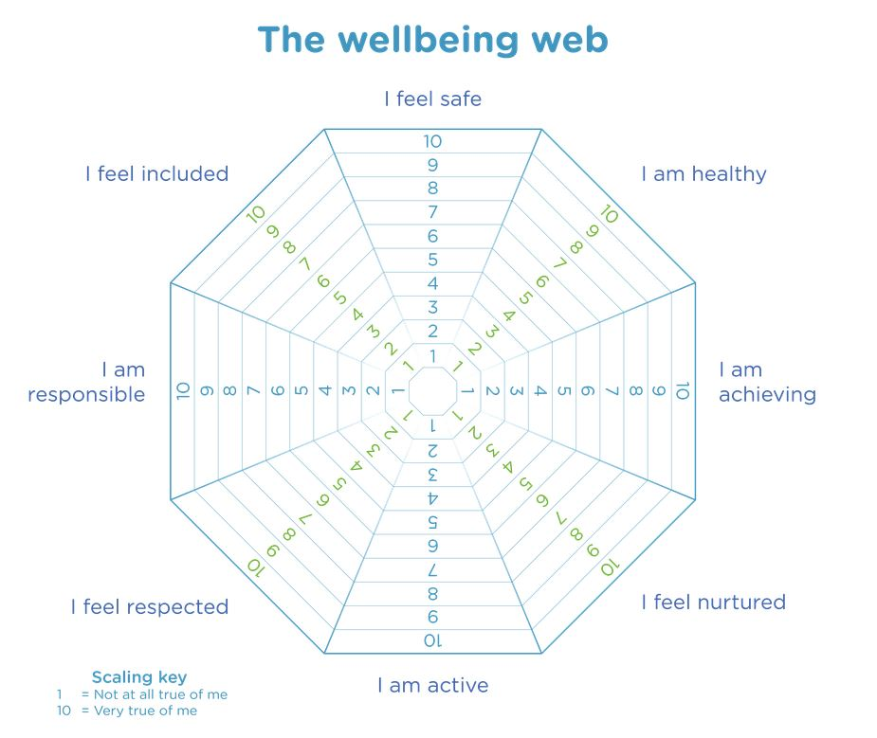

**How did I do?**