

Nursery to Primary

Transition Passport

***Name –***

***What I like to be called -***

***Nursery School –***

***Primary School -***

***Date of Birth –***

**These are my concerns-**

* *What worries the young person, causes them stress or difficult behaviours.*

**These are my strengths and interests-**

* *Please detail strengths and interests including academic and out of school.*

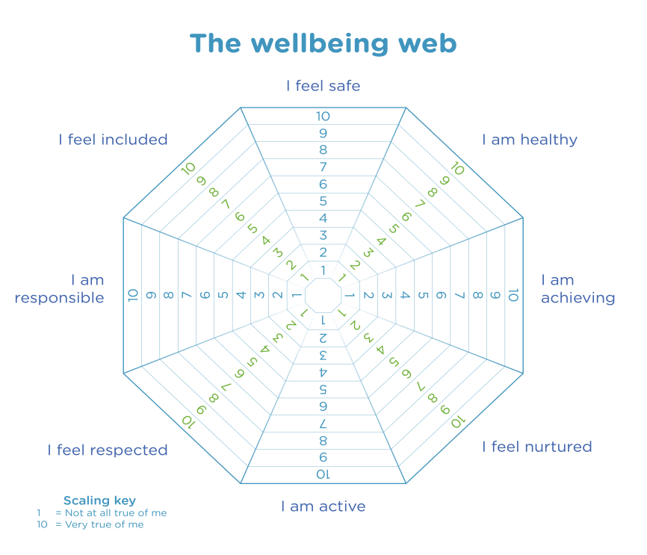

**My Favourite Activities at Nursery**

* Construction
* Water
* Sand
* Story Time
* Outside Area
* Gym
* Writing
* Numbers
* Art and Craft
* Reading
* Role Play
* Playing with Small World
* Game time
* Music

Other

**These are strategies to support me-**

* *What does the young person feel they need? Are there any agencies working with the child? Preferred learning style? Also consult support list.*

**I can do these things confidently**

* Use the toilet
* Change for gym
* Change my shoes
* Fasten my coat
* Use a knife and fork
* Ask for help

***-***

**Who is at home.**

**During Lockdown I enjoyed….**

**During Lockdown I did not enjoy…**

**These are my medical issues-**

* *Detail any medical issues.*