

Nursery to Primary

Transition Passport

***Name –*** Catherine Bloggs

***What I like to be called -*** Cath

***Nursery School –*** Balamory Nursery

***Primary School –*** Midtown Primary School

***Date of Birth –***  25/10/2015

**These are my concerns-**

* *What worries the young person, causes them stress or difficult behaviours.*
* I don’t like loud noises
* I cry when I am worried
* I am shy, I don’t speak to people I don’t really know.
* I like to watch a game or activity before I take part in it
* I hate being on stage, with people looking at me.
* I don’t like writing
* I am fearful of animals
* I don’t like losing a game
* I don’t eat at parties
* I don’t like to dress up

**These are my strengths and interests-**

* *Please detail strengths and interests including academic and out of school.*
* I love to play with cars
* I know lots about cars, the different types of manufacturers and models
* I like making race tracks
* I pretend that things are steering wheels
* I love Lightening Macqueen
* I can count to 20
* I know some sounds
* I can recognise my name
* I am not interested in animals
* I like to spend time in the caravan
* I like to go swimming
* I can ride a bike
* I enjoy soft play
* I love to eat snack and lunch at nursery
* I love listening to music

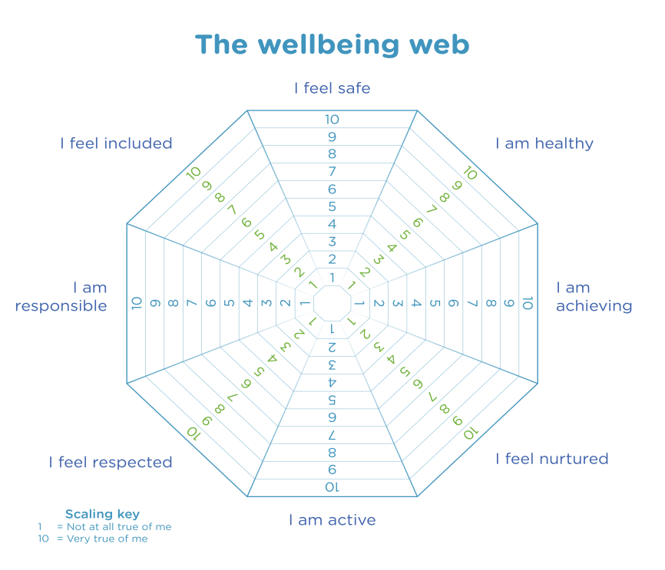

**My Favourite Activities at Nursery**

* **Construction**
* **Water**
* **Sand**
* **Story Time**
* Outside Area
* Gym
* Writing
* Numbers
* Art and Craft
* Reading
* Role Play
* **Playing with Small World**
* Game time
* Music

Other

**These are strategies to support me-**

* *What does the young person feel they need? Are there any agencies working with the child? Preferred learning style? Also consult support list.*
* Speak to me in a calm voice when I am upset
* Let me know about any changes
* Explain what is going to happen during the day
* Stick to a routine
* Let me play on my own
* Do not ask me to perform especially on a stage with an audience
* I don’t like lots of tasks
* I like a task and reward
* I wear glasses.

**I can do these things confidently**

* Use the toilet
* **Change for gym**
* Change my shoes
* Fasten my coat
* **Use a knife and fork**
* Ask for help

***-***

**Who is at home.**

My Mum and Dad.

My big brother Ali.

**During Lockdown I enjoyed….**

Baking

Playing in the garden and paddling pool

Playing with my cars and road mat

**During Lockdown I did not enjoy…**

I missed my cousins and grandparent

**These are my medical issues-**

* *Detail any medical issues.*
* I am have a gluten intolerance